**Module_7) jQuery Basic, Effects & Advanced**

* **What is jQuery?**
* jQuery is a JavaScript **Library**.
* jQuery **simplifies** JavaScript programming and it is **easy** **to** **learn**.
* jQuery only works if the proper **CDN** is added to the HTML file in the **<head>** tag.
* jQuery code is written in the **<script>** tag only.
* Syntax for jQuery is as follows:

**$(document).ready(function() {**

**});**

* **How to apply CSS using jQuery, how to add class and remove class in jQuery, jQuery animation?**
* How to apply CSS using jQuery:

Using an example as a reference for applying CSS as follows:

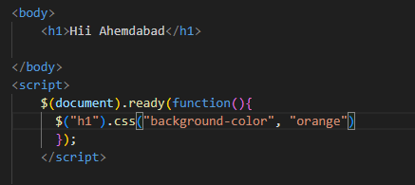

Following will be result:

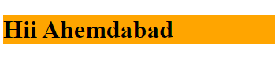

* How to add class and remove class in jQuery:

Using an example as a reference for adding and removing class as follows:

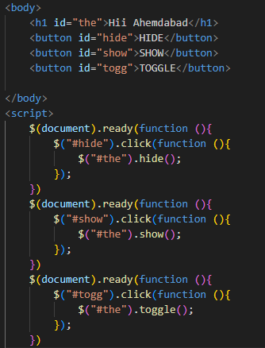

Following will be result:



* jQuery Animation:

Using an example as a reference for Animation:

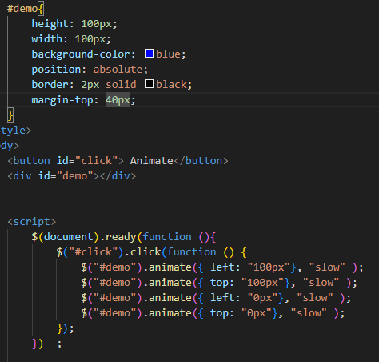

Following will be result:



* **How to create slider with animation?**
* Using an example as a reference for slider:

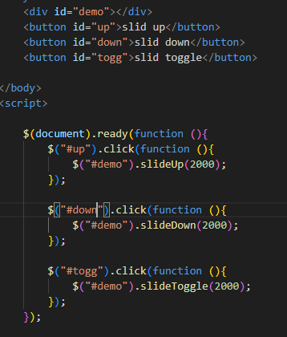

Following will be result:



* **Event bubbling tickling example:**

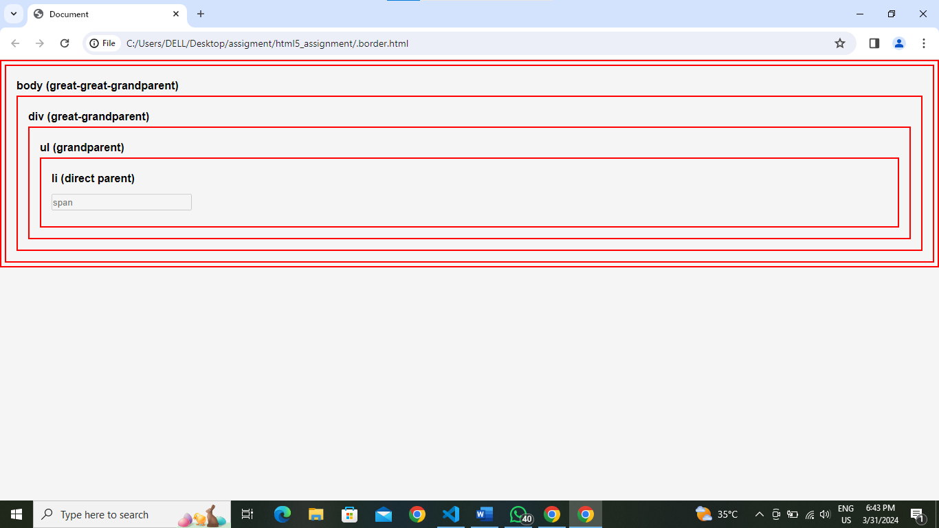**s**